TEXAS DEPARTMENT OF PUBLIC SAFETY
Report of Findings
[7/15/2026]

Sahas Roodkee
IS 3433-01T: Cyber Crime Investigations

Support Requested

An individual identified as Ethan Voss, employed at an Austin-area transmission facility within the ERCOT infrastructure, was recently apprehended following a residential search by the Texas DPS Cybercrime Unit. Authorities suspect Voss intended to sabotage a regional node during high-demand periods, an action that could have triggered widespread electrical failures across Central Texas infrastructure.

Goals:
1. How and when does Voss travel to meet the Iranian Sleeper Cell contact (Amir)?
2. Where does Voss likely stay during his (above) travel?
3. Where does Voss meet Amir? (address) What is Voss's likely route from the airport?
4. Is there relevant (to the investigation) communication in the Gmail Search Warrant return between Voss and Amir?
5. Is there relevant (to the investigation) communication in the Instagram Search Warrant return between Voss and Amir?
6. What is the Command-and-Control IP address on Thumb drive?
7. What is the URL on the Thumb drive?
8. What are the upcoming operation details? Provide screenshot(s) to support your findings.
9. The Intelligence Community (IC) reports that a PNG of a Regional Node Schematic (RTN-03) was observed in the wild (Internet) with an MD5 hash of: 7144de6de8cd77cbdf670c432c46b3df
Does this file appear on the Voss laptop?

Executive Summary

The Texas Department of Public Safety (DPS) Cybercrime Unit has just arrested and searched for the home of Ethan Voss, an employee at a regional transmission node near Austin, TX within the ERCOT-managed power grid. Investigators believe Voss was attempting to disrupt a regional transmission node during peak load, potentially causing cascading outages affecting critical services in Central Texas. During subject interviews, Voss disclosed he was in contact with an Iranian Sleeper Cell operative (named Amir) that provided Voss with a thumb drive.
I found evidence that will prove that Ethan Voss is guilty and put him behind bars. Analyzed Voss’s Gmail, Instagram and Thumb drive which connect Voss from Amir.

Evidence Inventory

[List all evidence examined]
Evidence Name | Description | Size | MD5 Hash
p | PNG of a Regional Node Schematic | 7.79MB | 7144de6de8cd77cbdf670c432c46b3df
Gmail_Search_Warrant_Return.mbox | Gmail Warrant | 65.2KB | eee3f2c3c548937b5ac3af3a2fb65b99
instagram_search_warrant_return.pdf | Instagram Warrant | 150KB | 53222585860a665ec678f2af322c06ce
Voss_Thumbdrive.001 | Image File | 500MB | 17fee6c40e66efe1fd55cc3d736b4f18

Methodology / Tools

The following tools and methods were used:
• Autopsy 4.23.1 for forensic analysis of email artifacts
• Bstrings for extracting URL and Command-and-Control IP address from Thumb drive image.
• AccessData FTK Imager 4.3.0.18 for a
• QuickStego for steganographic analysis of disk images.
• Hash comparison (MD5) to validate file identity

Findings

Email Communication
Voss first contacted Amir through email.
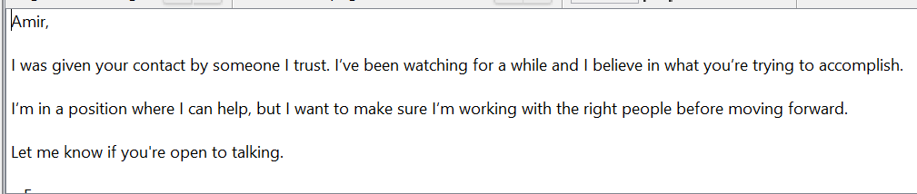
Figure 1: Voss email to Amir

Amir replied by giving him his Instagram handle.
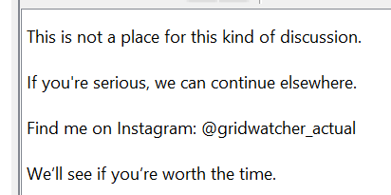
Figure 2: Amir's reply to Voss

Instagram Communication
Amir asked Voss to travel to the Union Station area. 1701 Wynkoop St, Denver, CO 80202.
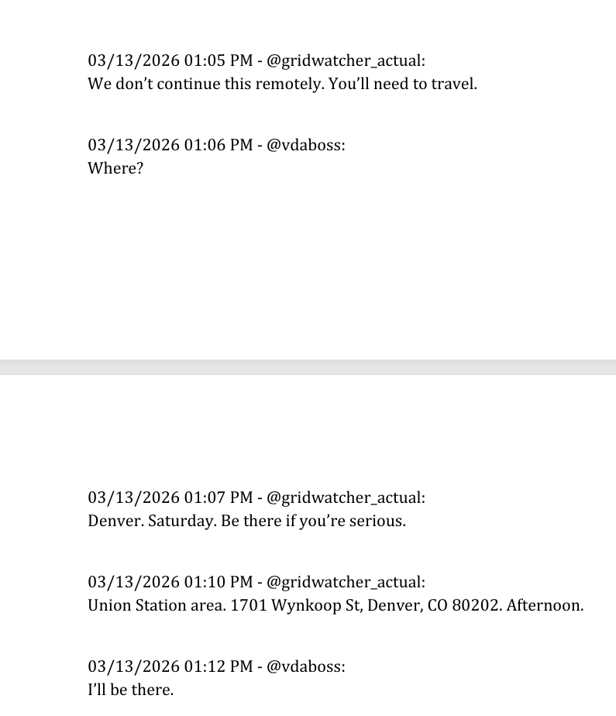
Figure 3: Amir asked Voss to travel to Denver

The date Voss went to meet Amir is 03/16/2026.
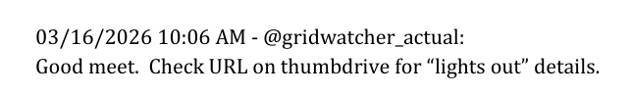
Figure 4: Date on which meeting happened

Travel Details
Most likely location Voss during his travel would be The Crawford Hotel
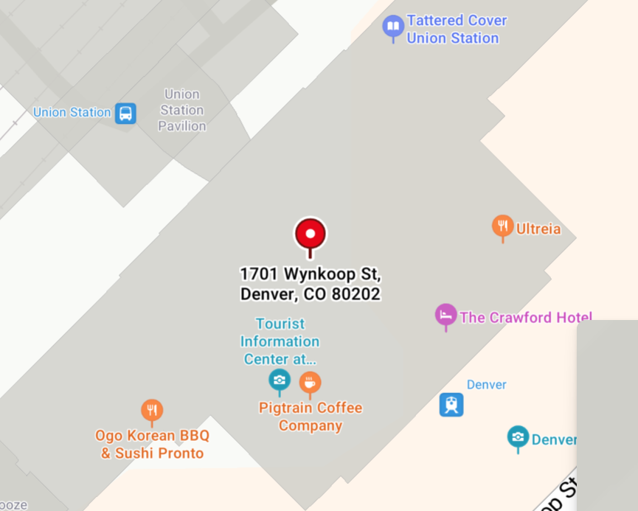
Figure 5: Place where Voss likely would have stayed.

The most likely path he would have taken from the airport to the meeting location is below.
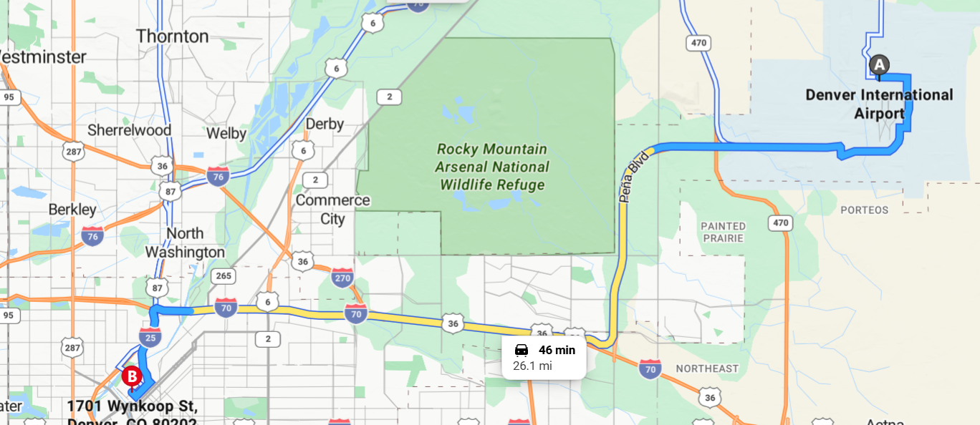
Figure 6: Most likely the route Voss would have been taken from airport.

Thumb Drive Investigation
Amir gave Voss a thumb drive and said it had a URL. He said it was hidden in a image.
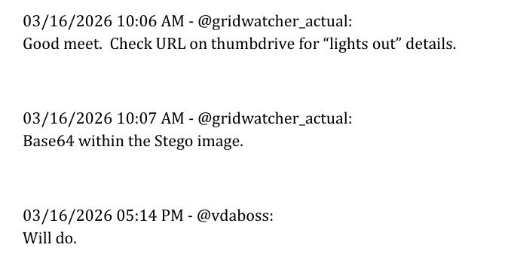
Figure 7: Amir gave a Thumb drive to Voss

After analyzing the drive there was nothing in the image. So, I used Bstring to analyze if there is any URL in the strings of the image and found a URL
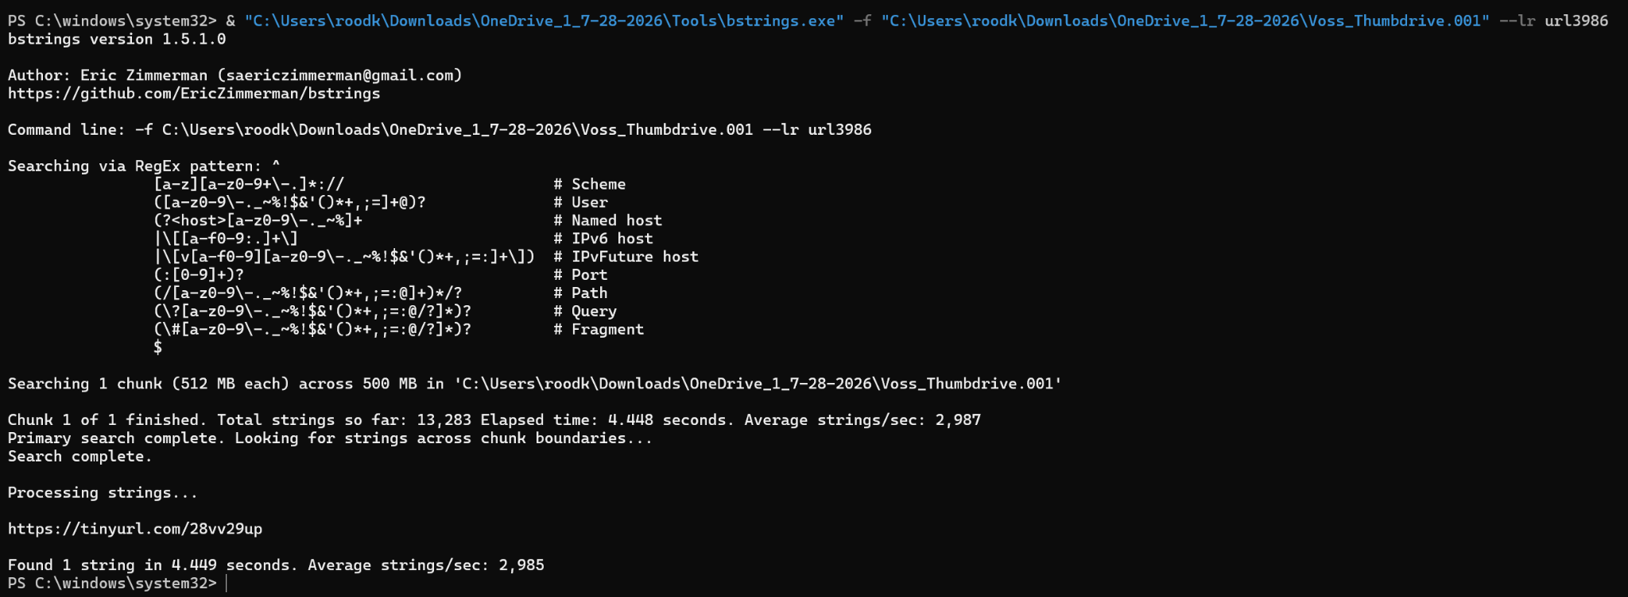
Figure 8: Used Bstring to get the URL

I also looked for Command-and-Control IP address on the Thumb drive and found one.
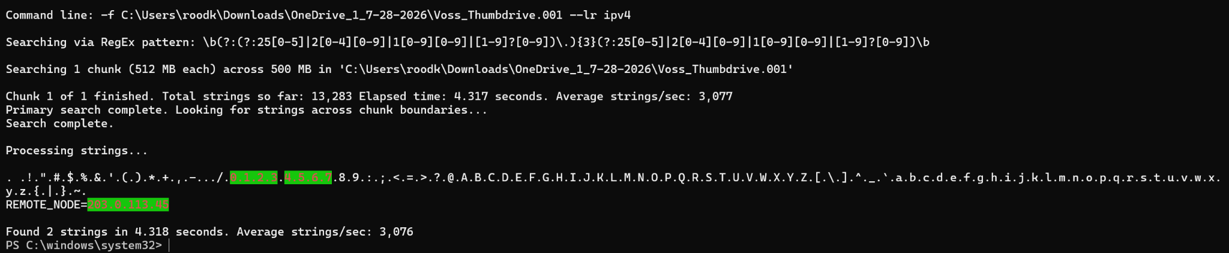
Figure 9: Used Bstring to get Command-and-Control IP address

I searched for the URL I found on the drive, and it led to this website.
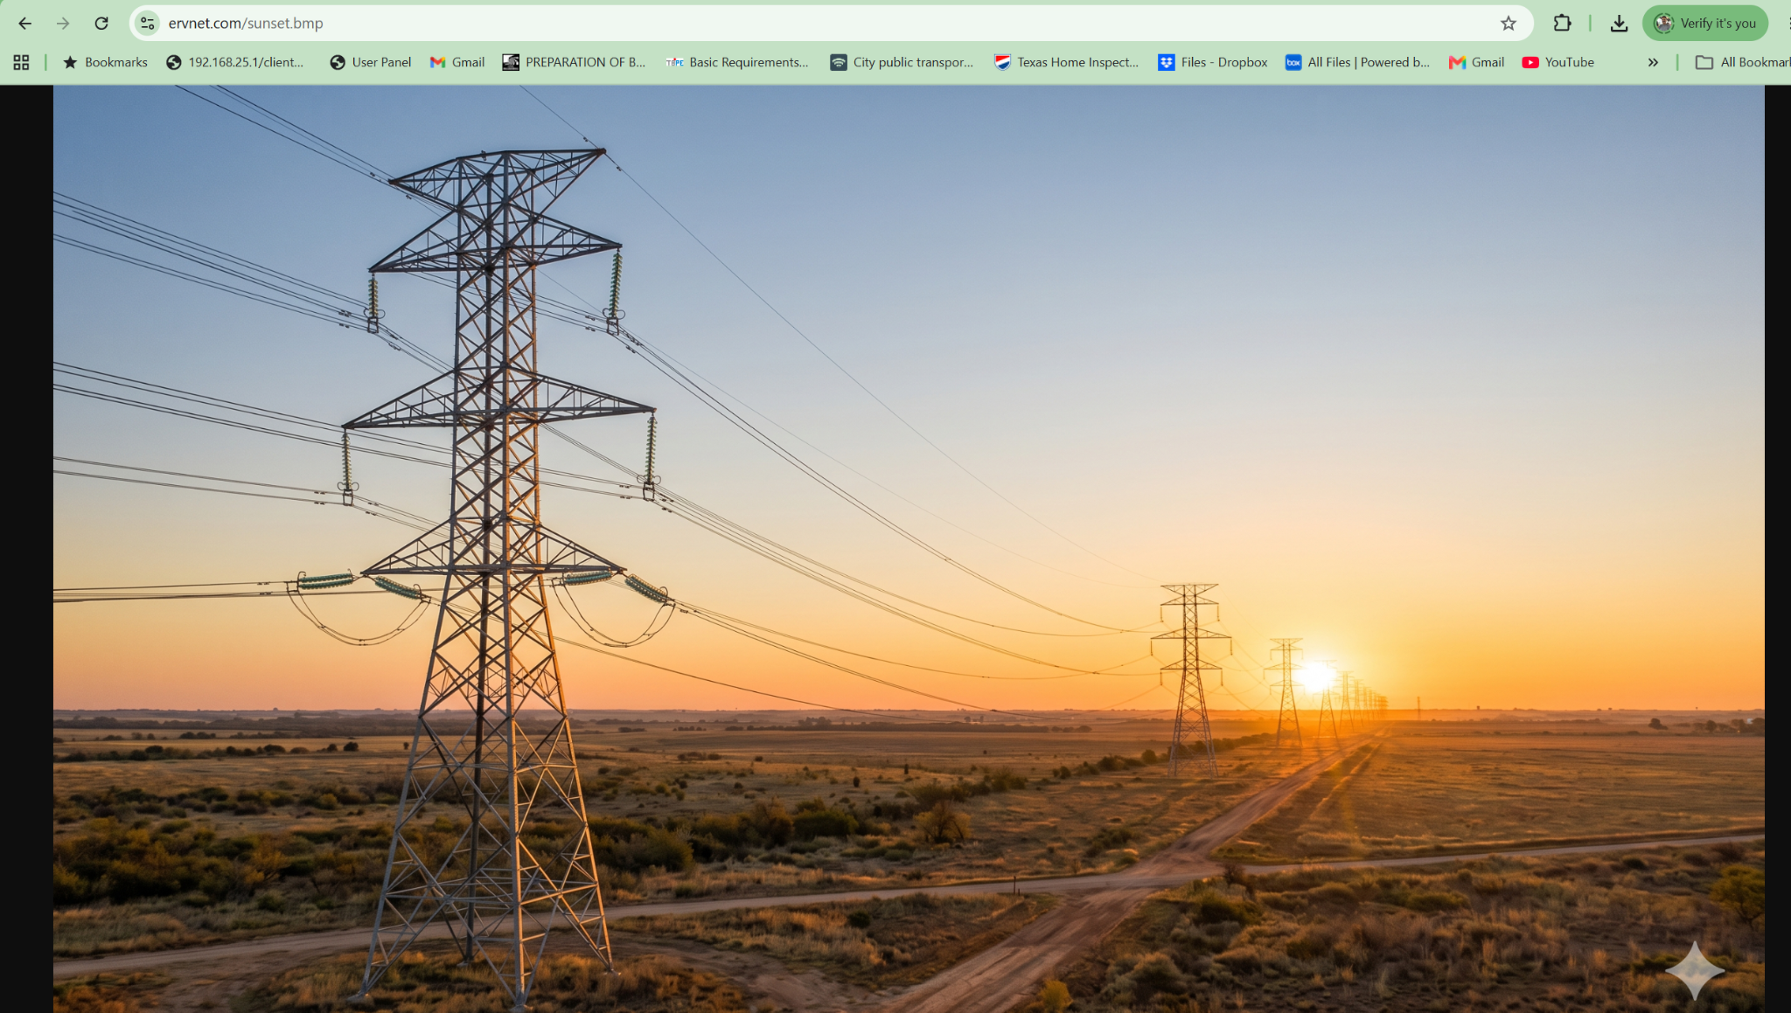
Figure 10: URL led me to this website

Then I searched Voss Files to look for a PNG of a Regional Node Schematic (RTN-03) was observed in the wild (Internet) with an MD5 hash of: 7144de6de8cd77cbdf670c432c46b3df
And I found it.
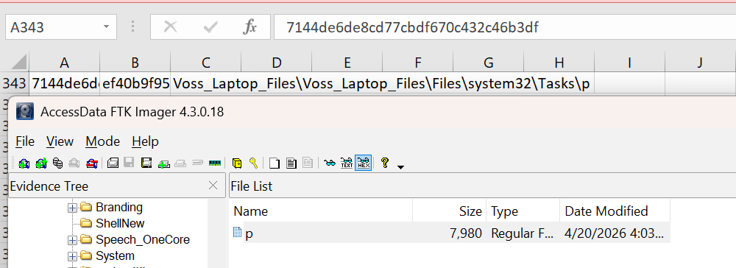
Figure 11: Found the file with the matching MD5 Hash.

Analysis / Interpretation

The combined evidence demonstrates a structured workflow:
• Communication Layer:
On Gmail and Instagram
• Instruction Layer:
Thumb drive to conceal URL and Command and Control IP address
• Execution Layer:
Picked up thumb drive in Denver
Voss demonstrates:
• Active coordination with Amir (Iranian sleeper cell)
• Intent to sabotage a regional node

Conclusion

Evidence supports that Ethan Voss was actively participating in sabotage a regional node with the help of an Irani sleeper cell Amir.
Voss:
• Communicated with Amir through email and Instagram.
• Meet Amir in Denver and got a thumb drive with URL
• Used bstrings to get URL and command and control IP address
•Had a PNG of a Regional Node Schematic (RTN-03) was observed in the wild (Internet) with an MD5 hash of: 7144de6de8cd77cbdf670c432c46b3df

References

- Autopsy 4.23.1
- Bstrings
- QuickStego
- Google Maps
- AccessData FTK Imager 4.3.0.18

